This Document is related to surcharge – FIN Pricing Team prepared by Akshaya (QA) for internal reference purposes.
This document is break down into parts with the userstory 1201311
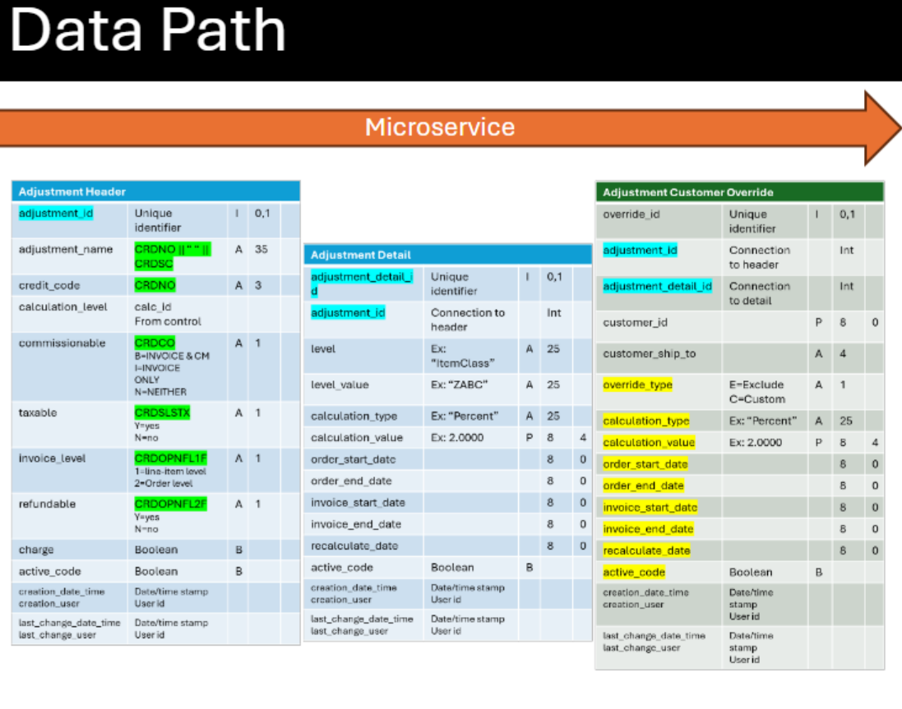

1. Database Tables (Left Side)
Adjustment Header Table:
- Primary configuration table with fields:
  - adjustment_id (unique identifier)
  - adjustment_name (CRDNO)
  - credit_code
  - calculation_level
  - commissionable (Y/N)
  - taxable (Y/N)
  - invoice_level
  - active_code (Boolean)
  - Various timestamp fields
Adjustment Detail Table:
- Contains calculation rules:
  - adjustment_detail_id
  - level (e.g., "ItemClass")
  - level_value
  - calculation_type ("Percent")
  - calculation_value
  - order_start_date/end_date
  - active_code
Adjustment Customer Override Table:
- Customer-specific rules:
  - override_type (E=Exclude, C=Custom)
  - customer_id
  - customer_ship_to
  - calculation details
  - date ranges
2. Output Structure (Right Side)
Microservice Outbound - Order Level:
- Order ID (A7)
- Customer ID (P80)
- Ship To (A4)
- Total Surcharge (P132)
Microservice Outbound - Adjustment Level:
- Item ID (A15)
- Status codes:
  - 0 = API OFF
  - 1 = NONE APPLIED
  - 2 = APPLIED
Microservice Outbound - Adjustment Details:
- credit_code (CRDNO)
- adjustment_name
- Adjustment amount (calculated)
- invoice_level
- taxable status
- commissionable status
- Quantity
- calculation_value (Ex: 2.0000)
- calculation_type ("Percent")
- applied_level ("ItemClass")
- applied_level_value
- charge (Boolean)

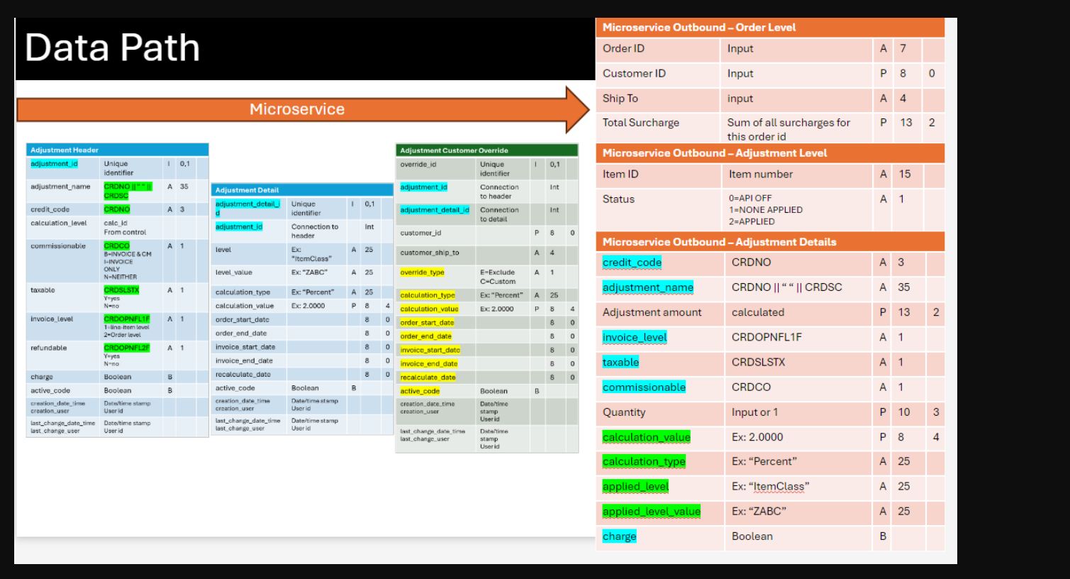
Data Flow Process:
- Input Processing:
  - System receives Order ID, Customer ID, and Ship To
  - Validates against Header table for active adjustments
- Calculation Flow:
  - Checks Adjustment Header for active records
  - References Adjustment Detail for calculation rules
  - Verifies Customer Override for exceptions
  - Applies appropriate calculation type and value
- Output Generation:
  - Compiles all calculations at item level
  - Accumulates total surcharge at order level
  - Returns complete adjustment details with appropriate status codes
The rightmost columns (A7, P80, etc.) appear to be field specifications for length and type of data storage.
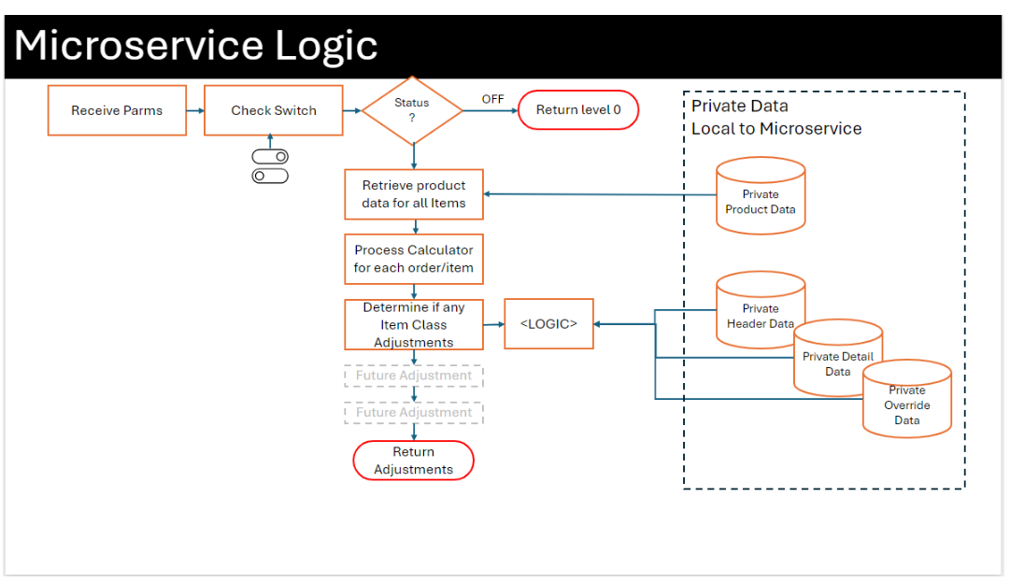
- Starting Point
  - "Receive Parms": System gets input data (like order details, customer info)
  - "Check Switch": Checks if the service is ON or OFF (like a light switch)
- Initial Decision
  - If switch is OFF → "Return level 0" (service doesn't process anything)
  - If switch is ON → Continues to next steps
- Main Process Flow (when ON)
  - First retrieves all product data for the items in the order
  - Runs calculations for each order/item
  - Checks for any Item Class Adjustments (like import surcharges)
- Data Sources (shown in right side boxes)
  - The system uses four private databases:
    - Product Data (item information)
    - Header Data (adjustment rules)
    - Detail Data (specific adjustment details)
    - Override Data (customer-specific rules)
- Future Planning
  - Shows placeholder boxes for "Future Adjustment" (system is designed to add more adjustment types later)
- End Point
  - "Return Adjustments": Sends back the final calculated adjustments
Think of it like a decision tree where each step depends on the previous one, similar to:
- Checking if a store is open (switch)
- If open, looking up prices (product data)
- Applying any special discounts (adjustments)
- Calculating final price (return adjustments)
About the surcharge story testing focus
1.Switch Functionality Tests
a) Switch OFF Scenarios:
• Verify status code returns 0
• Confirm stub out values remain unchanged
• Validate no calculations are performed
b) Switch ON Scenarios:
• Verify system processes new logic
• Validate connection to private data tables
• Confirm appropriate status codes (1 or 2) are returned

2. Data Validation Tests
a) Product Data Validation:
• Valid ItemNumber in tblItemList
• Valid ItemClass-code mapping
• Invalid/Non-existent item numbers
• Multiple items in single order
b) Adjustment Header Validation:
• Active vs Inactive adjustments
• Valid credit_codes
• Valid adjustment_names
• Valid/Invalid date ranges
c) Adjustment Detail Validation:
• ITEMCLASS level validations
• Multiple active surcharges
• Date range boundaries
• Active/Inactive status

3. Surcharge Calculation Tests
a) Basic Calculations:
• Single item, specified quantity
• Single item, no quantity (default=1)
• Multiple items in order
• Zero price items
b) Rounding Logic:
• Values ending in decimals (0.34 → 1.00)
• Values just over whole numbers (1.01 → 2.00)
• Values close to next dollar (2.89 → 3.00)
c) Total Surcharge Accumulation:
• Multiple line item
• Mixed status items (some with surcharge, some without)
• Order-level total calculation

4. Customer Override Tests
a) Exclusion Override (Type 'E'):
• Matching customer_id with ship_to
• Matching customer_id with blank ship_to
• Non-matching customer_id
• Invalid customer_id
b) Custom Override (Type 'C'):
• Valid date range with custom calculation
• Expired date range
• Future date range
• Custom calculation values
• Multiple overrides for same customer
c) Ship-to Variations:
• Specific ship-to address
• Blank ship-to
• Multiple ship-to for same customer

5. Status Code Validation Tests
a) Status 0 Scenarios:
• API OFF conditions
• Verify no adjustment details

b) Status 1 Scenarios:
• No active adjustment headers
• Non-matching item class
• Outside date range
• Excluded customer
• Invalid calculation scenarios
c) Status 2 Scenarios:
• Valid surcharge application
• Correct adjustment details
• Complete data population

6. Edge Case Tests
a) Date Boundary Tests:
• Order date = start date
• Order date = end date
• Order date outside range
b) Data Combination Tests:
• Multiple active adjustments
• Multiple customer overrides
• Mixed status items in single order
c) Error Handling:
• Missing required fields
• Invalid data types
• Null values
• Database connection issues

7. Input Validation Tests
a) Order Level:
• Valid/Invalid order_id
• Valid/Invalid customer_id
• Various ship_to formats
b) Item Level:
• Valid/Invalid item_id
• Various quantity formats
• Price variations
• Multiple line items

Table Validation
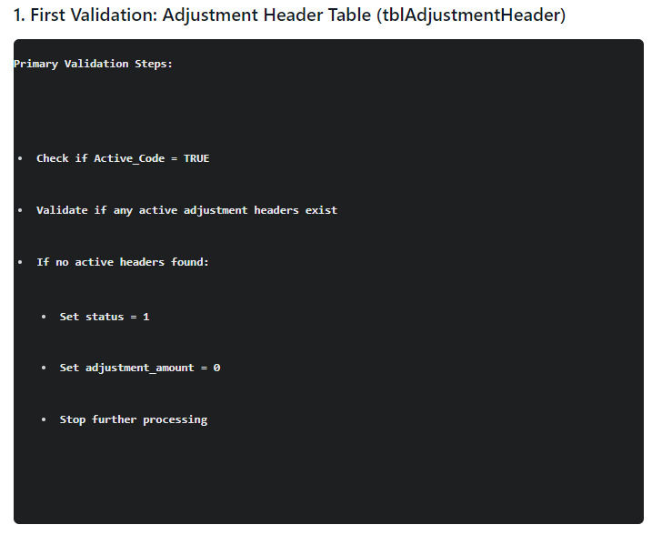
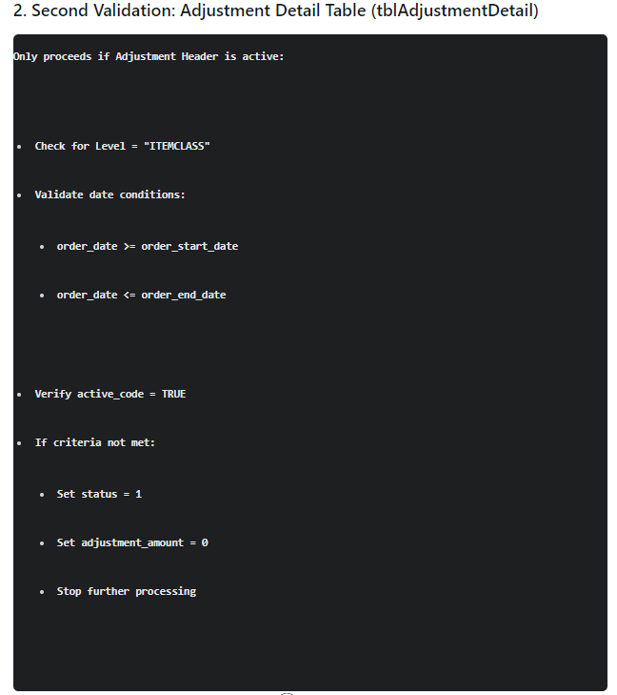
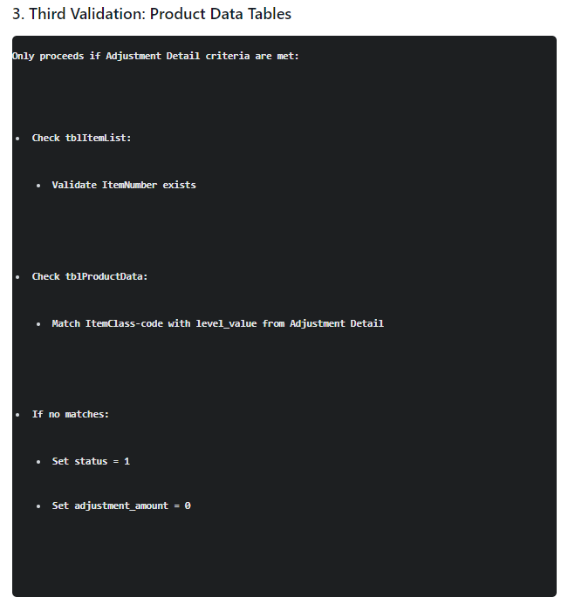
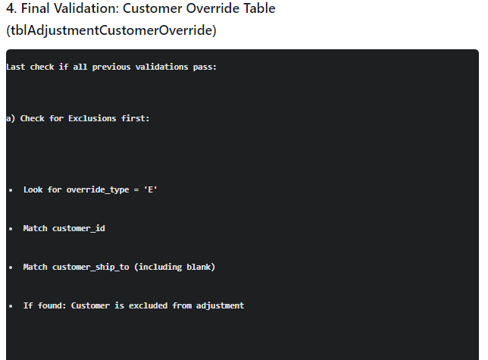
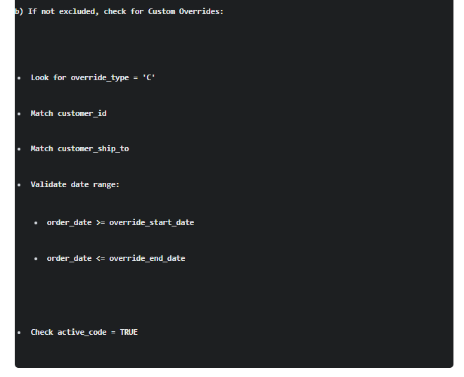
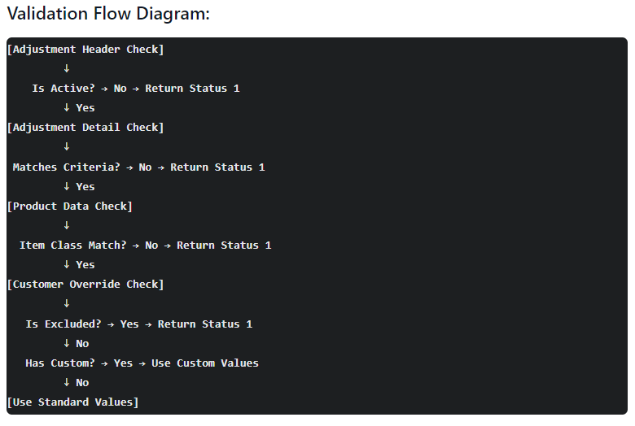
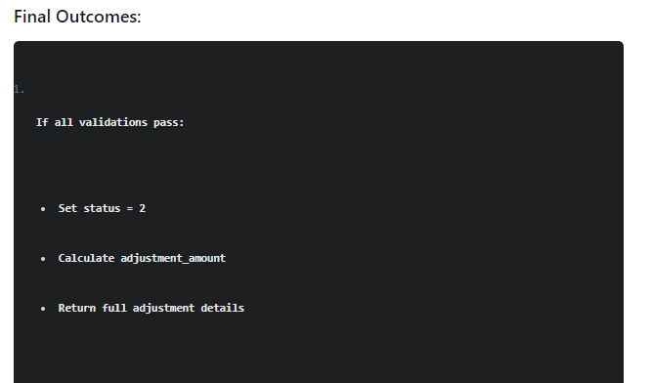
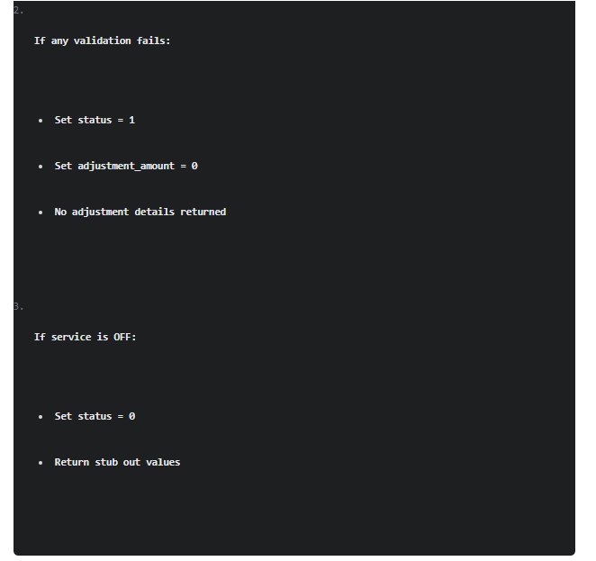
Functionality flowchart
Link: file:///C:/Users/ANarayanan/Downloads/mermaid-05a47ff8-c9f0-494c-9e07-647818621cda-73-0-1%20(2).svg

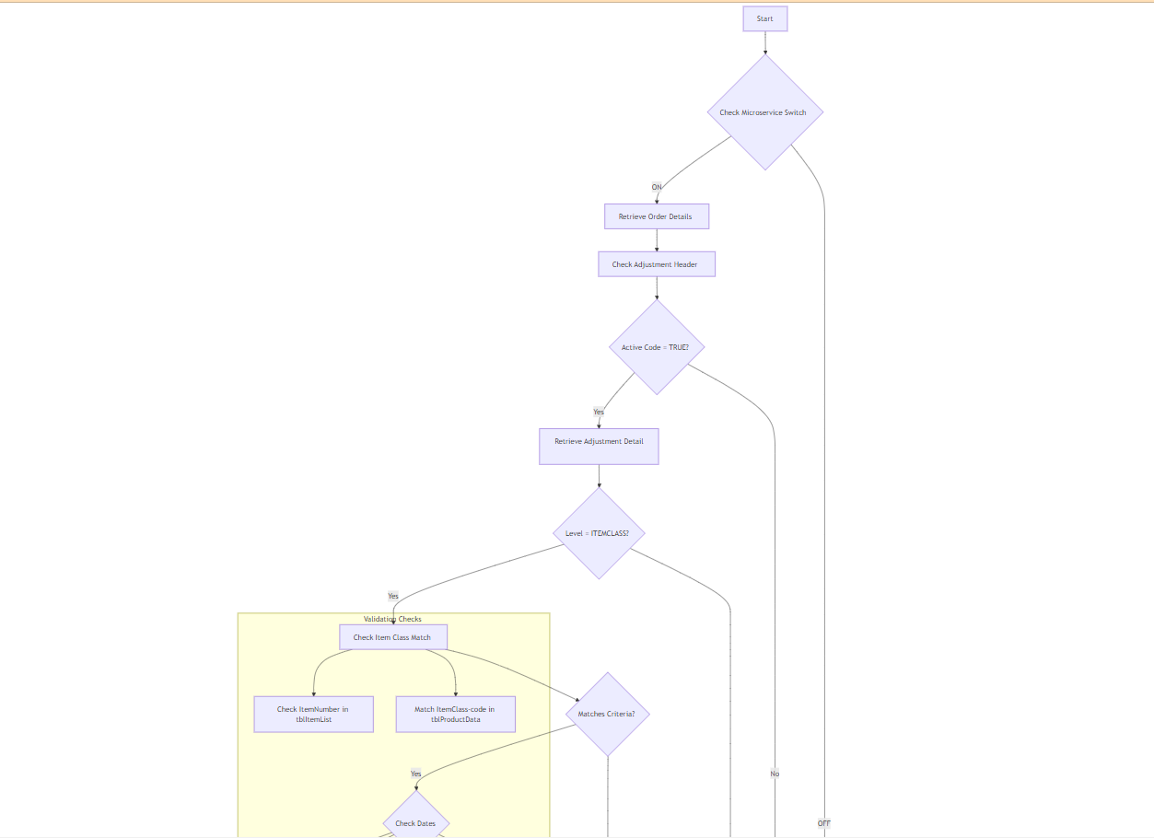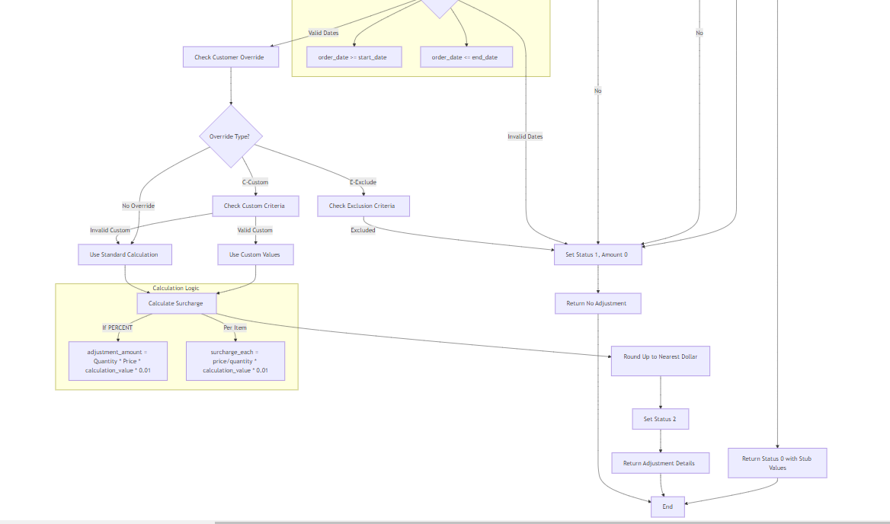
This flowchart illustrates the main logic flow of the Import Surcharge microservice. Would you like me to explain any specific part in more detail?
Note: The flowchart shows:
- Initial switch check
- Adjustment Header validation
- Adjustment Detail verification
- Customer Override processing
- Calculation logic
- Status setting and return values
The subgraphs show additional detail for calculation and validation steps.

Flowchart Detailed flowchart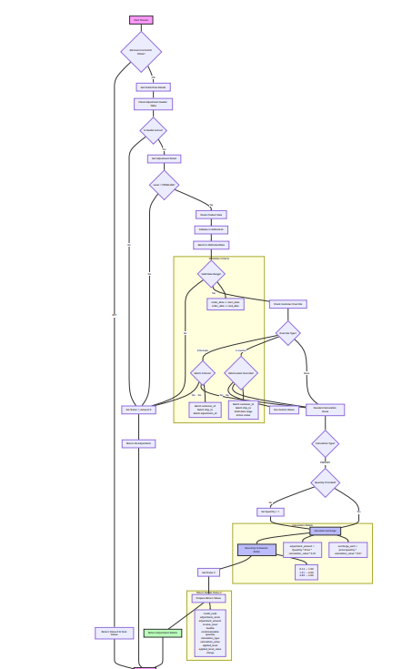

This enhanced flowchart includes:
- Detailed validation steps
- Calculation subgraph showing formulas
- Complete validation criteria
- Return value details
- Color coding for key steps
- All possible paths and outcomes
- Specific conditions for each decision point
- Status setting points
- Comprehensive override handling

Flowchart Process-HighLevel

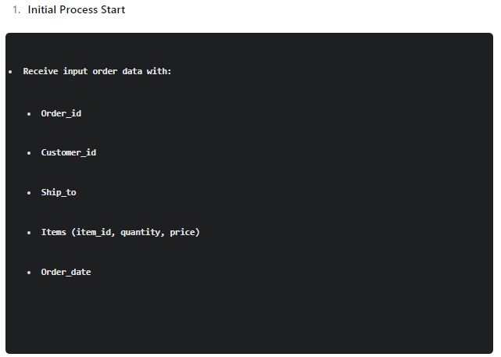
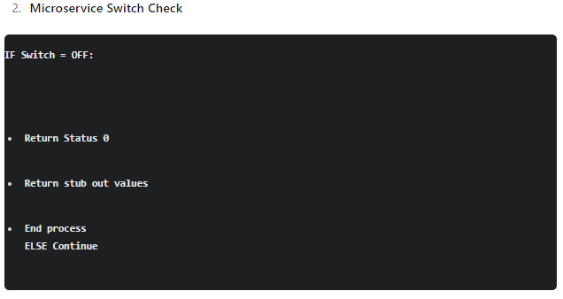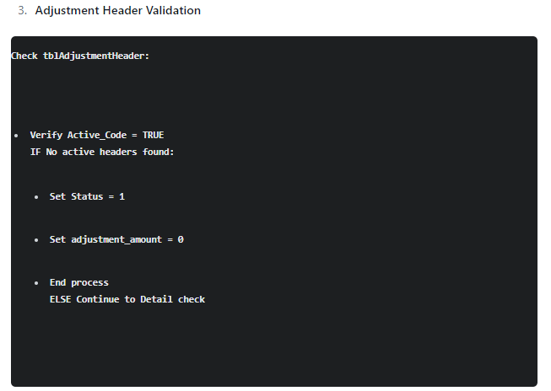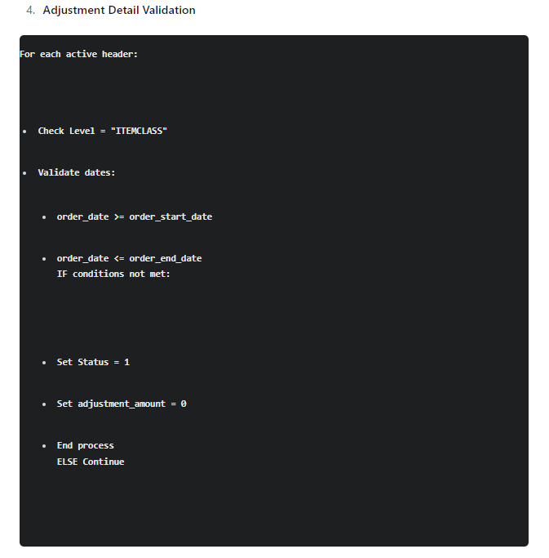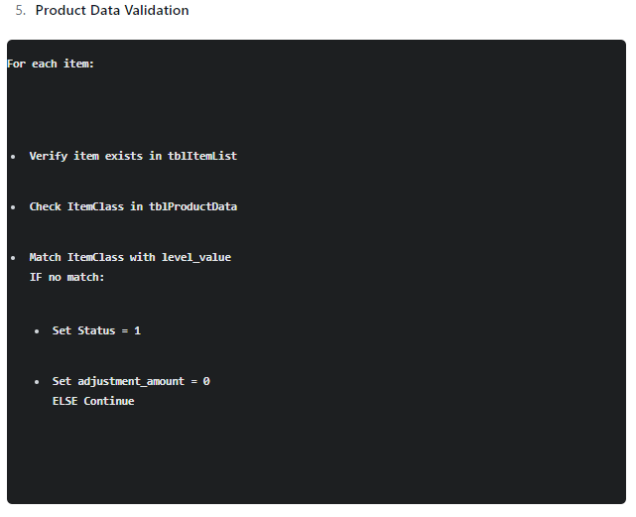
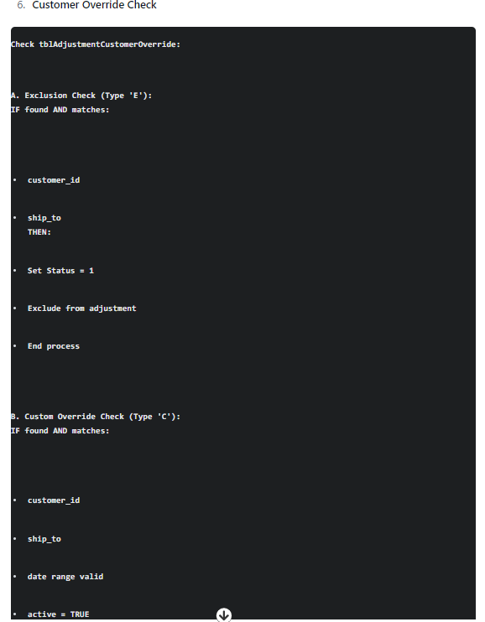
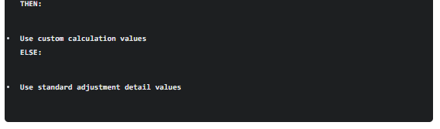
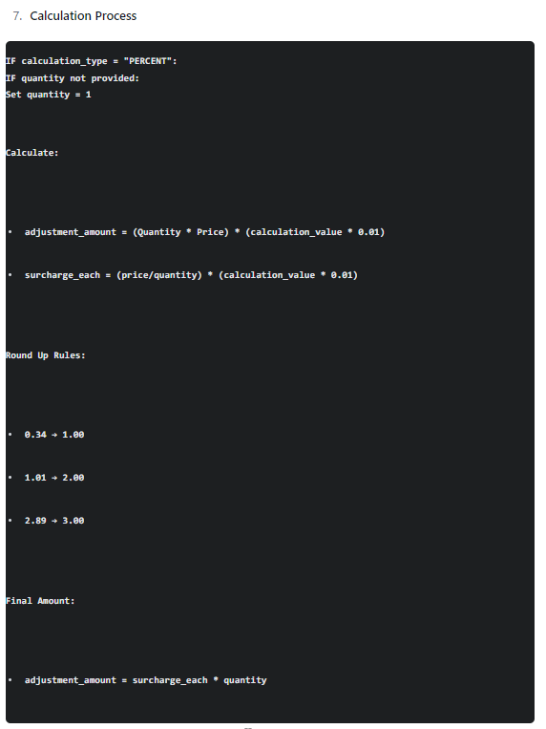
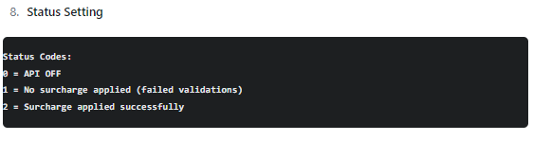
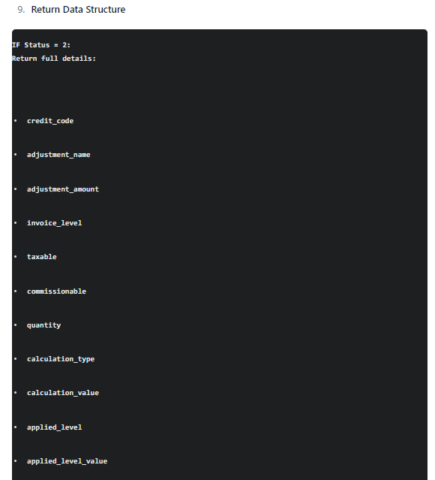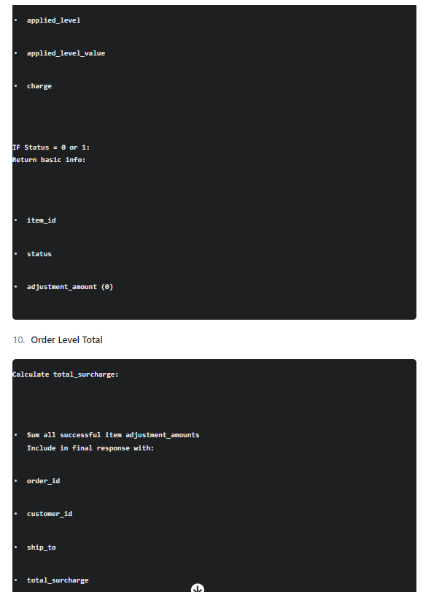
This process ensures:
- Proper validation at each step
- Correct application of surcharges
- Appropriate handling of overrides
- Accurate calculations
- Complete response data

Flowchart Detailed process
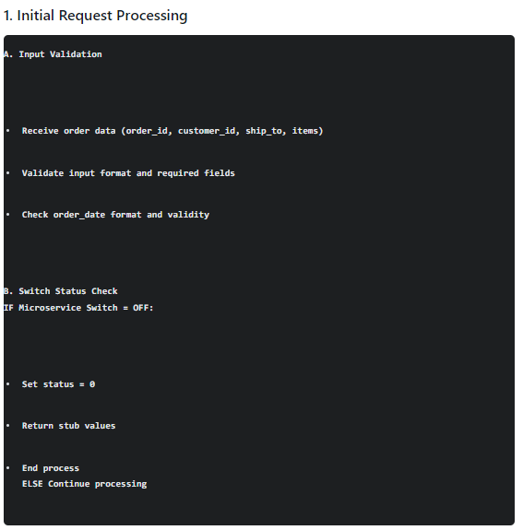
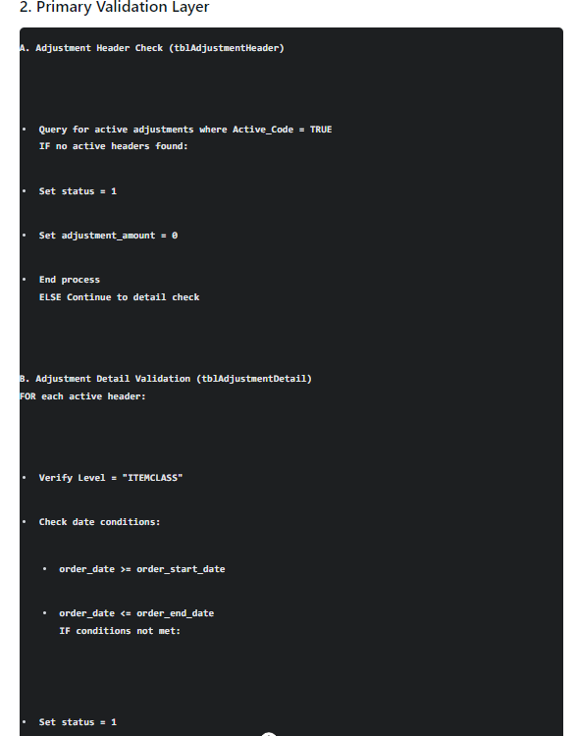
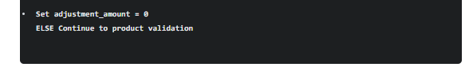

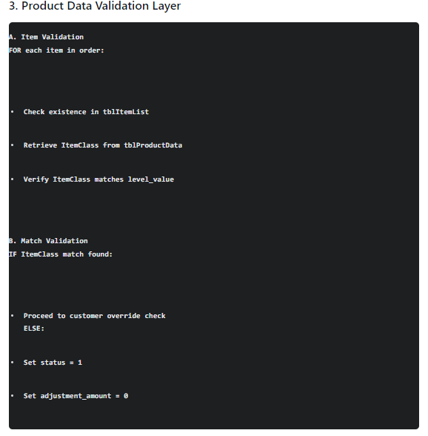
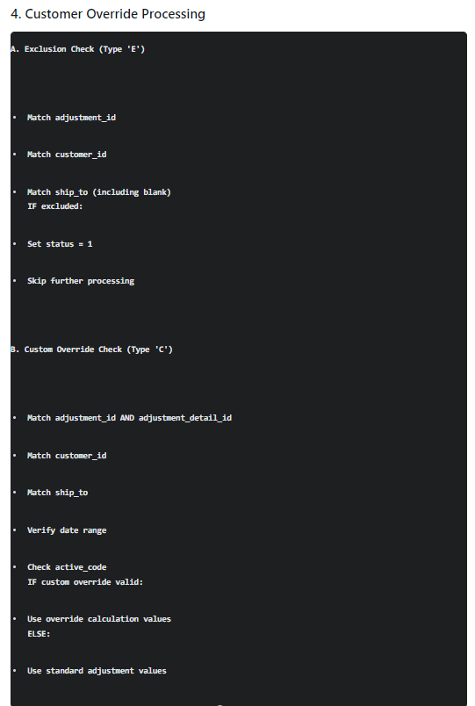
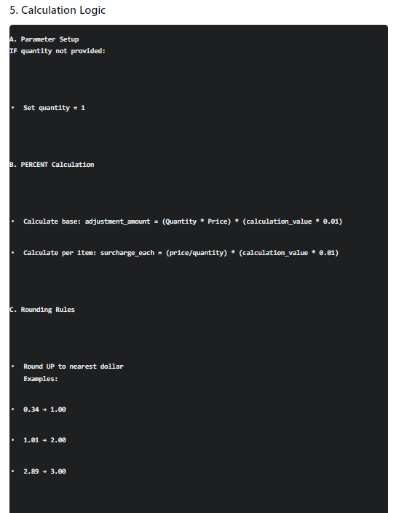
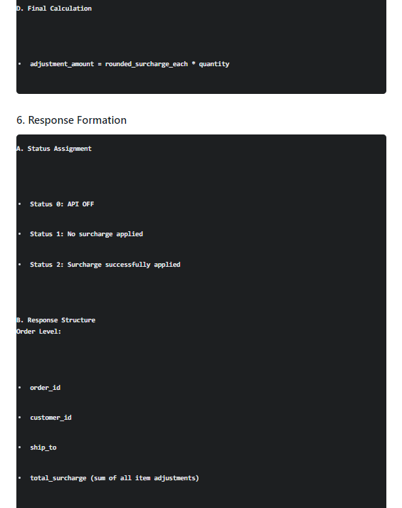
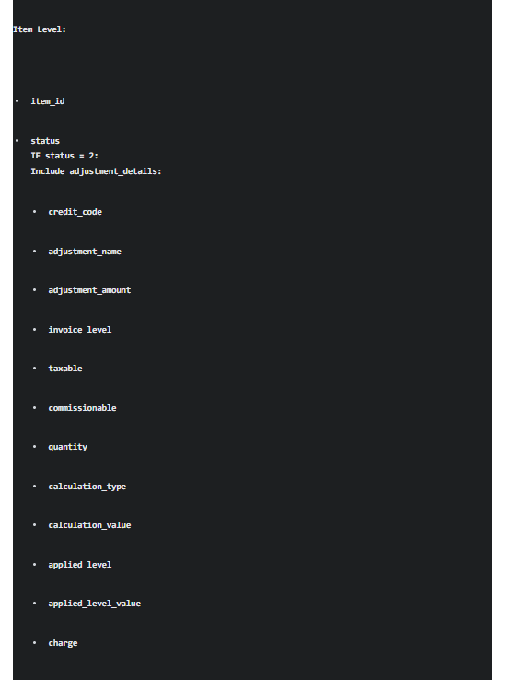
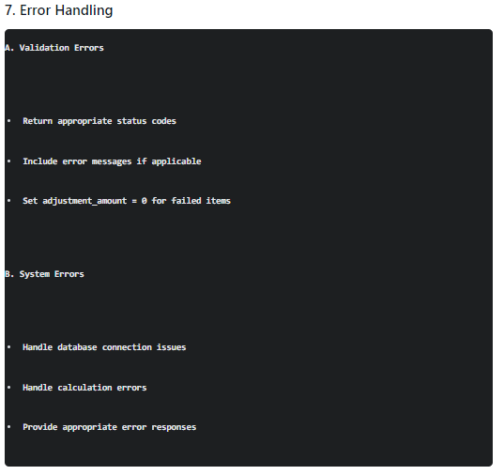
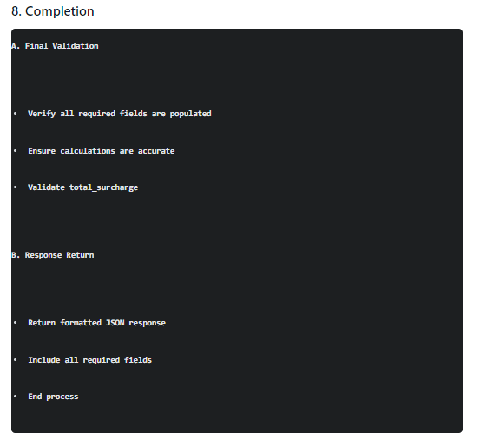
JSON API
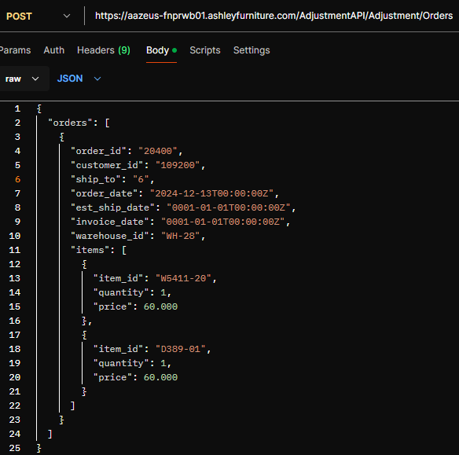
Output: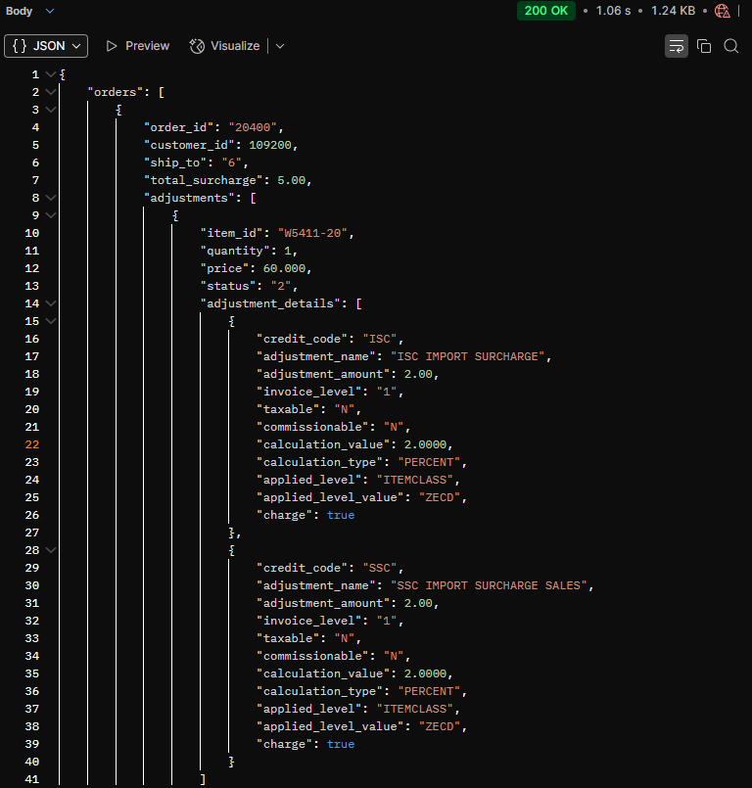
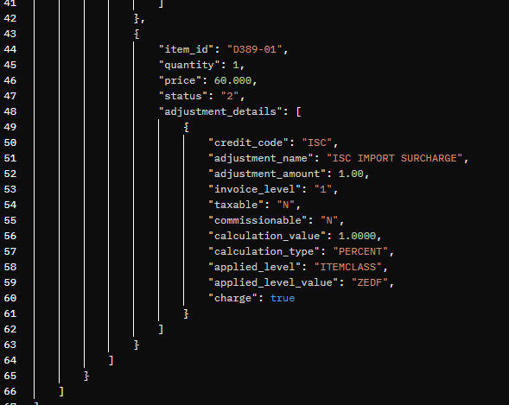
Key points about this output structure:
- Order Level
  - Maintains original order_id, customer_id, ship_to
  - total_surcharge is sum of all item adjustments (4.00 = 2.00 + 2.00)
- Item Level
  - Each item has status = 2 (assuming surcharge applies)
  - Calculation for each item: (60.00 * 2%) = 1.20, rounded up to 2.00
- Adjustment Details
  - Full details included for status 2 items
  - All required fields present as per specifications
Note: This assumes:
- Microservice is ON
- Items qualify for surcharge
- No customer overrides
- 2% calculation value
- Items belong to applicable item class

New Scenario:
This was Highlighted in the Scrum Call discussion with Damo and William: Scenario of a customer that has an override Type E and an Override type C for different adjustment id's. In the example the customer will be excluded(type E) from the adjustment zero(ISC) but would return the override adjustment(type C) for adjustment 1(SSC).

